**Location:**

Maastricht University

Faculty of Arts and Social Sciences

Soiron Building, Spiegelzaal

Grote Gracht 82 ()

6200 MD Maastricht

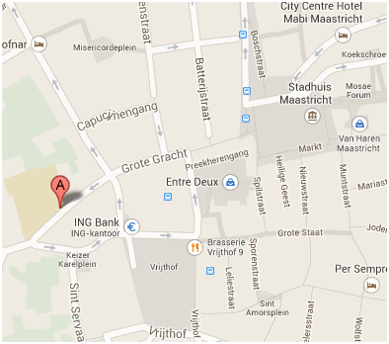

O**rganizers:**

Carine Germond & Wolfram Kaiser



**Crisis, Ideas and Policy Transformation:**

**Experts and Expertise in European International Organizations,**

**1973-1987**

**30-31 January 2014**

**Maastricht University**

**Faculty of Arts and Social Sciences**

**Soiron Building, Spiegelzaal**



**THURSDAY, 30 JANUARY 2014**

13:30-14:00 Arrival of participants and coffee

**14:00-14:30 Introduction**, C. Germond/W. Kaiser

**14:30-16:00 Session 1: Cross-sectoral Institutional Expertise (Chair: Carine Germond)**

Mathieu Leimgruber (University of Geneva)/Alix Heiniger (University of Lausanne)/Samuel Beroud (University of Geneva), *A Pilot Fish Ahead of the Sharks? Economic and Statistics Experts*

Paul Stephenson (Maastricht University/Sciences Po Paris), *Starting From Scratch? Experts and the Rise of Auditing*

Discussant: Kiran K. Patel (Maastricht University)

16:00-16:30 Coffee break

**16:30-18:00 Session 2: Experts in the Agricultural Sector (Chair: Wolfram Kaiser)**

Carine Germond (Maastricht University/University of Portsmouth), *Advocating or Opposing Reform? Agricultural Policy*

Claire Dunlop (University of Exeter), *Epistemic Communities and Policy Learning: the Hormones Saga*

Discussant: Sophie Vanhoonacker (Maastricht University)

20:00 Dinner

**FRIDAY, 31 JANUARY 2014**

**09:00-10:30 Session 3: Experts in the Industrial and Service Sectors I (Chair: Carine Germond)**

Wolfram Kaiser (University of Portsmouth), *Globalization, Economic Transformation and the Environmental Challenge: Heavy Industry*

Arthe van Laer, *Technological Innovation and Policy Change: Telecommunications*

Discussant: Vincent Lagendijk (Maastricht University)

10:30-11:00 Coffee break

**11:00-12:30 Session 4: Experts in the Industrial and Service Sectors II (Chair: Wolfram Kaiser)**

Sally Sheard (University of Liverpool), *Equity, Effectiveness and/or Efficiency: Health Policy*

Monika Baár (University of Groningen), *From Social Welfare to Human Rights*: *Disability Policy*

Discussant: Karen Heard-Lauréote (University of Portsmouth)

12:30-13:30 Lunch

**13:30-15:00 Session 5: Experts in Environment and Development Policies (Chair: Carine Germond)**

Jan-Henrik Meyer (University of Aarhus), *The Myth of the Independent Expert: Environmental Policy*

Christian Salm (University of Portsmouth), *Accelerating Economic and Social Progress*: *Development Aid Policy*

Discussant: Raf de Bont (Maastricht University)

15:00-15:30 Coffee break

**15:30-17:00 Session 6: Experts in Banking and Foreign Policy Cooperation (Chair: Wolfram Kaiser)**

Alexis Drach (European University Institute), *Networks and Financial Globalisation: Banking Supervision*

Alexander Reinfeldt (University of Hamburg), *Between Cyprus and Afghanistan: European Political Cooperation*

Discussant: Aneta Spendzharova (Maastricht University)

**17:00-18:00 Conclusion**, C. Germond/W. Kaiser

**General discussion**

**18:00-19:00 Studying Experts from an Interdisciplinary Perspective: Potentials, Challenges and Pitfalls (Chair: Wolfram Kaiser)**

Tannelie Blom (Faculty of Arts and Social Sciences), Carine Germond (Faculty of Arts and Social Sciences), Ellen Vos (Faculty of Law), Kai Michelsen (Faculty of Health, Medicine and Life Sciences)

20:00 Dinner