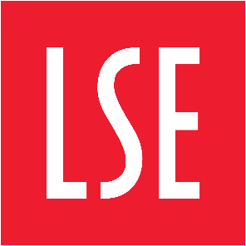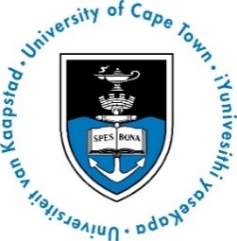

BEYOND THE PERIPHERY:
UNPACKING AFRICAN AGENCY IN GLOBAL POLITICS

Au-delà de la Périphérie – l’Afrique dans les Relations Globales : actions, influence(s) et défis

10 October 2016,
Salle des Conférences, 9h-17h00
CERI-Sciences Po

PROGRAMME

9h-10h

KEYNOTE SPEAKER: African “Agency” in Global Politics: What Does It Entail?

Prof. Funmi Olonisakin, Founding Director of the African Leadership Centre (King's College London/University of Nairobi)

Discussant: Dr. Karen Smith, University of Cape Town (South Africa)

10h – 11h30

PANEL 1: THE ROLE OF IDENTITY AND IDEOLOGY IN SHAPING AFRICA’S POSITION ON THE GLOBAL STAGE

Chair : Prof. Frédéric Ramel (CERI/Sciences Po)

The Role of Berlin and Bandung in the Making of Global Africa

Prof. Oka Obono, University of Ibadan (Nigeria)

Pan-Africanism and the African Union as a collective international actor

Prof. Tim Murithi, University of Free State (South Africa)

11h30 – 13h

PANEL 2: BEYOND THE STATE: AFRICAN SUBSTATE ACTORS AS AGENTS OF CHANGE

Chair: Dr. Folashade Soule-Kohndou, (CERI-Sciences Po)

Translating Global Norms into Local Action: The Campaign against Gender-Based Violence in Africa

Dr. Peace Medie, Legon Centre for International Affairs and Diplomacy, University of Ghana, (Ghana)/ Global Leaders Fellow (Oxford-Princeton University)

Local resilience in the fight against Boko Haram in Sokoto State, and Borno State in Nigeria

Akinola Olojo, Université Paris Descartes/African Leadership Centre (King's College London/University of Nairobi).

14h30-16h

PANEL 3: WHO DEFINES THE RULES? UNCOVERING AFRICAN AGENCY IN INTERNATIONAL RULES-SETTING

Chair: Prof. Chris Alden, London School of Economics and Political Science (United Kingdom)

Africa's New Authoritarians: International Assistance and Authoritarian Statebuilding in Contemporary Africa

Dr. Jonathan Fisher, University of Birmingham (United Kingdom)

A Protracted Quandary of Liberal Peace and Political Islam in Sub-Saharan Africa: Recycling Failures in ‘Greater’ Sudan

Prof. Atta El-Battahani, University of Khartoum (Sudan)

16h-17h00

Concluding remarks: Studying Africa and IR: the Potential of Agency

Prof. William Brown, Politics and International Studies department, The Open University (United Kingdom)

Coordinators:

Dr. Folashadé Soulé-Kohndou, Research associate, CERI/Sciences Po/ Lecturer (Sciences Po)

Mohamed Diatta, PhD candidate, CERI/Sciences Po

Dr. Karen Smith, Senior Lecturer, Department of Political Studies, University of Cape Town (UCT)

Prof. Chris Alden, Associate Professor, Department of International Relations, London School of Economics and Political Science (LSE)

